**Assignment #1 – Windows Concepts**

**Tasks**

* Explain the 3 different types of Windows logins.

**Purpose**

* **Clarify –** Distinguish between Local, Cloud, and Active Directory logins in Windows.
* **Summarize –** Be able to explain each type of Windows login.

**Assignment**

* **In a text box:** Explain in your own words the different types of Windows logins, their purposes, and when each might be used.

Types of Windows Logins

1. **Local Login**: This type of login involves authenticating directly against the local user database of the Windows operating system installed on a specific machine. It is primarily used for individual computers or devices that are not connected to a network or domain. Local logins provide access to resources and services available only on a particular device.

2. **Cloud Login**: Cloud login, also known as Microsoft Account login, offers a convenient way to authenticate to Windows. By using a Microsoft Account (formerly known as Windows Live ID), users can seamlessly integrate with Microsoft's cloud services such as OneDrive, Outlook.com, and Microsoft Store. This type of login enables the synchronization of settings and preferences across multiple devices and provides easy access to cloud-based features and storage.

3. **Active Directory Login**: Active Directory (AD) login is a secure option used in network environments where multiple computers are connected to a central directory service known as Active Directory Domain Services (AD DS). Users log in using credentials stored centrally on the Active Directory server. AD logins offer centralized management of user accounts, group policies, and network resources, ensuring

Assignment #2 – Windows Concepts

**Tasks**

* Explain the 2 types of native shells in Windows Server.

**Purpose**

* **Clarify** – Distinguish between the two types of native shells used in Windows Server.
* **Summarize** – Be able to explain each type of shell, its specific functions, and typical use cases.

**Assignment**

* + In a text box Describe in your own words the different types of native shells in Windows Server, detailing their purposes and functionalities.

Types of Native Shells in Windows Server

1. **Command Prompt (cmd.exe)**: Command Prompt is a command-line interpreter that allows users to interact with the operating system by typing commands. It provides a text-based interface for executing various system commands, scripting tasks, and managing files and directories. Command Prompt is commonly used for administrative tasks, batch scripting, and system troubleshooting.
2. **PowerShell**: PowerShell is an advanced command-line shell and scripting language designed for system administrators to automate administrative tasks and manage system configurations. It offers powerful scripting capabilities and access to .NET Framework libraries, enabling the automation of complex tasks, system management, and remote administration. Due to its flexibility and extensibility, PowerShell is increasingly becoming the preferred choice for Windows Server administration.
   * Screenshots: Provide screenshots or diagrams illustrating the interface and possible configurations or commands typical for each shell. 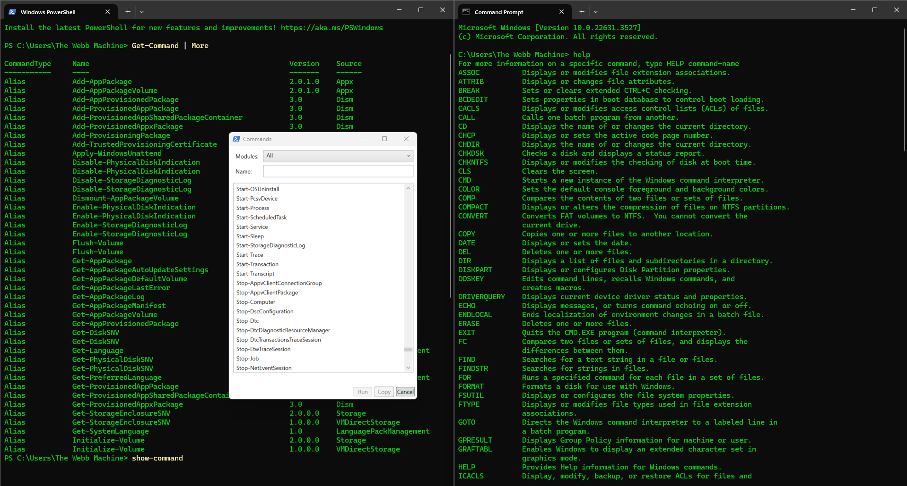

Going to the home search toolbar on the desktop, you can enter cmd to load the command interface for both Powershell and Command Prompt. To view commands for Command Prompt, you can enter the help command to list all available commands installed on the computer. To list all available commands for Powershell installed on the compute, you can enter the get-command | more command or the show-command to list all commands available in a separate window.

Assignment #3 – Windows Concepts

1. **Ribbon Interface**: The Ribbon interface is located at the top of the File Explorer window and contains various tabs, each grouping related commands together. The tabs typically include Home, Share, View, and (sometimes) File. Users can access commands related to file management, sharing, viewing options, and more from these tabs. The Ribbon interface provides a more intuitive and organized way for users to access File Explorer's features compared to traditional menu bars.

*Explanation of Windows File Explorer Options*

1. **Quick Access Toolbar**: The Quick Access Toolbar is a customizable toolbar located at the top left corner of the File Explorer window, next to the Ribbon interface. It provides quick access to frequently used commands such as Undo, Redo, Delete, and Rename. Users can customize the Quick Access Toolbar by adding or removing commands based on their preferences, allowing for a personalized and efficient workflow.

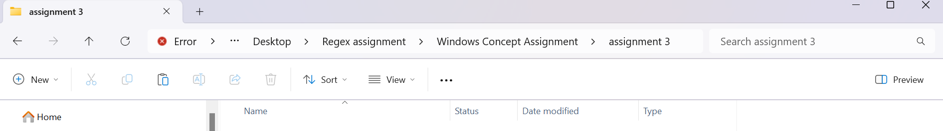

1. **Navigation Pane**: The Navigation Pane is located on the left side of the File Explorer window and displays a hierarchical view of the file system. It includes shortcuts to frequently accessed folders such as Desktop, Downloads, Documents, Pictures, and drives and network locations. The Navigation Pane allows users to navigate the file system easily and quickly access their preferred locations.

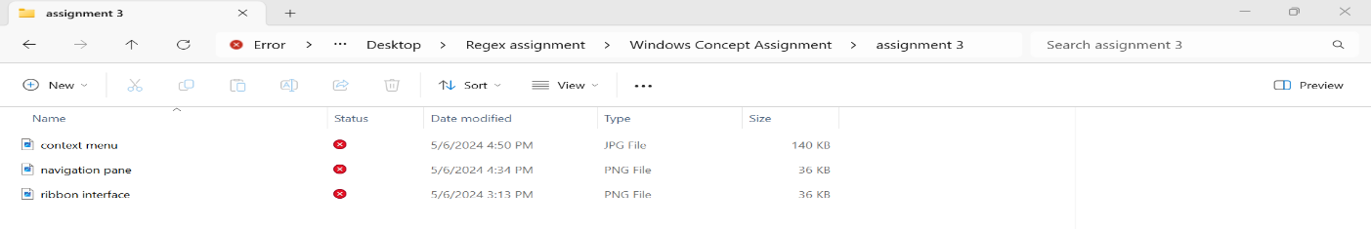

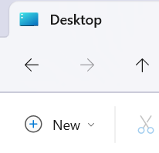

1. **Search Box**: Windows 11 File Explorer features a Search Box at the window’s top right corner. The Search Box lets users quickly search for files, folders, and other items within the current directory or the entire file system. Users can enter keywords or file names into the Search Box, and File Explorer will display relevant results in real time, making it easy to locate specific items.
2. **File Menu**: The File Menu in Windows 11 File Explorer is accessible by clicking on the "File" tab in the Ribbon interface. It offers a range of options for managing files and folders, including creating new folders, renaming items, copying, and pasting files, and accessing properties. The File Menu also provides options for managing the current File Explorer window, such as opening a new window or closing the window.



1. **File Preview**: Windows 11 File Explorer includes a preview pane allowing users to preview certain file types' contents without opening them in external applications. Users can enable the preview pane by clicking on the "View" tab in the Ribbon interface and selecting the "Preview pane" option. Once enabled, users can select a file, and its contents will be displayed in the preview pane, providing a quick glimpse of its contents.

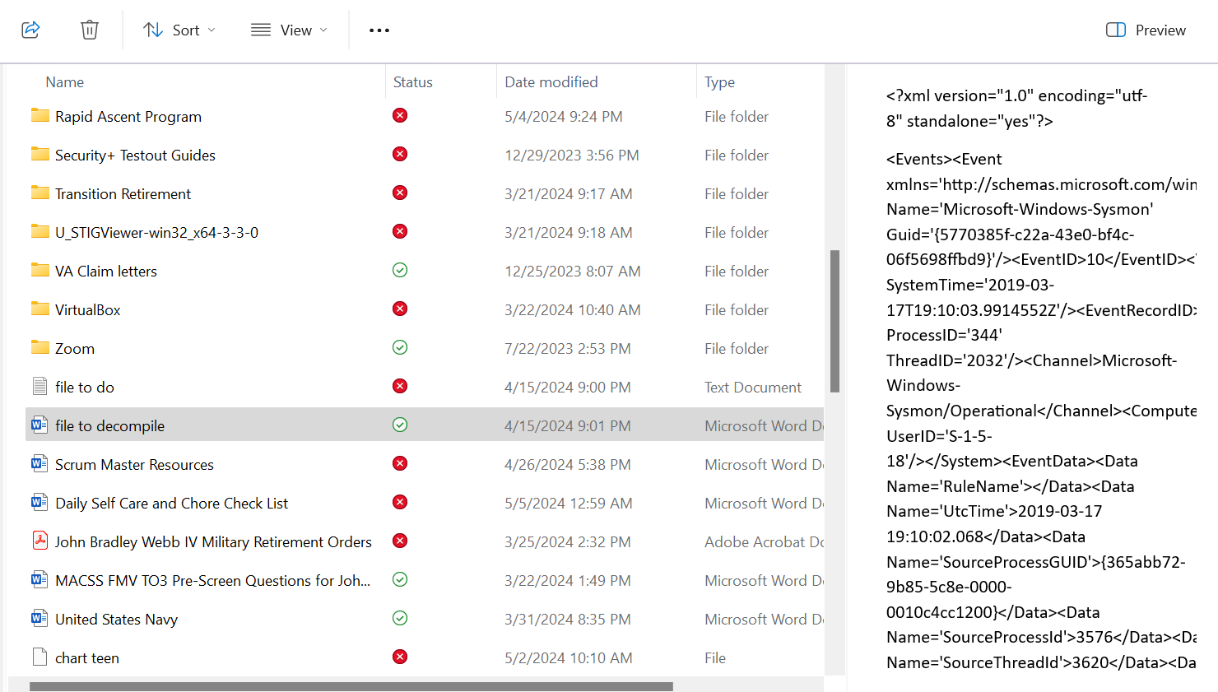

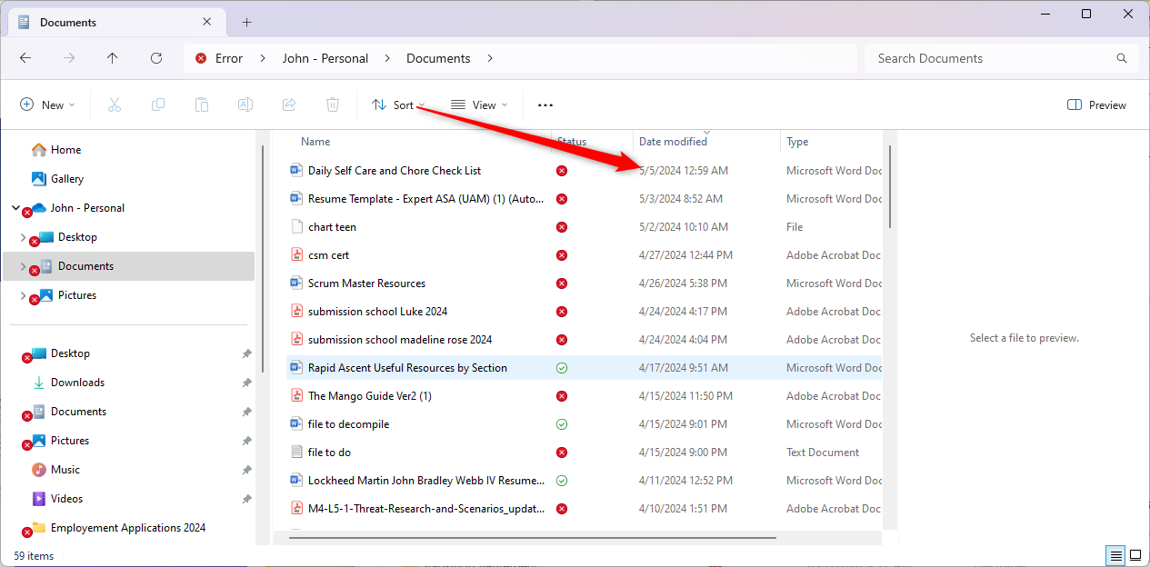

1. **View Changes**: Users can change the Windows 11 File Explorer view mode to suit their preferences and requirements. The available view modes include List, Tiles, Details, and Content, each offering a different way to display files and folders in the file listing area. Users can switch between view modes using the options available in the Ribbon interface or by right-clicking on a space in File Explorer and selecting the desired view mode from the context menu.
2. **Sorting Options**: Windows 11 File Explorer provides various sorting options to help users organize files and folders based on different criteria, such as name, date modified, file type, and size. Users can sort files in ascending or descending order by clicking on the column headers in File Explorer, allowing for easy customization and organization of file listings. Here the sort tab was used to sort by modified date.

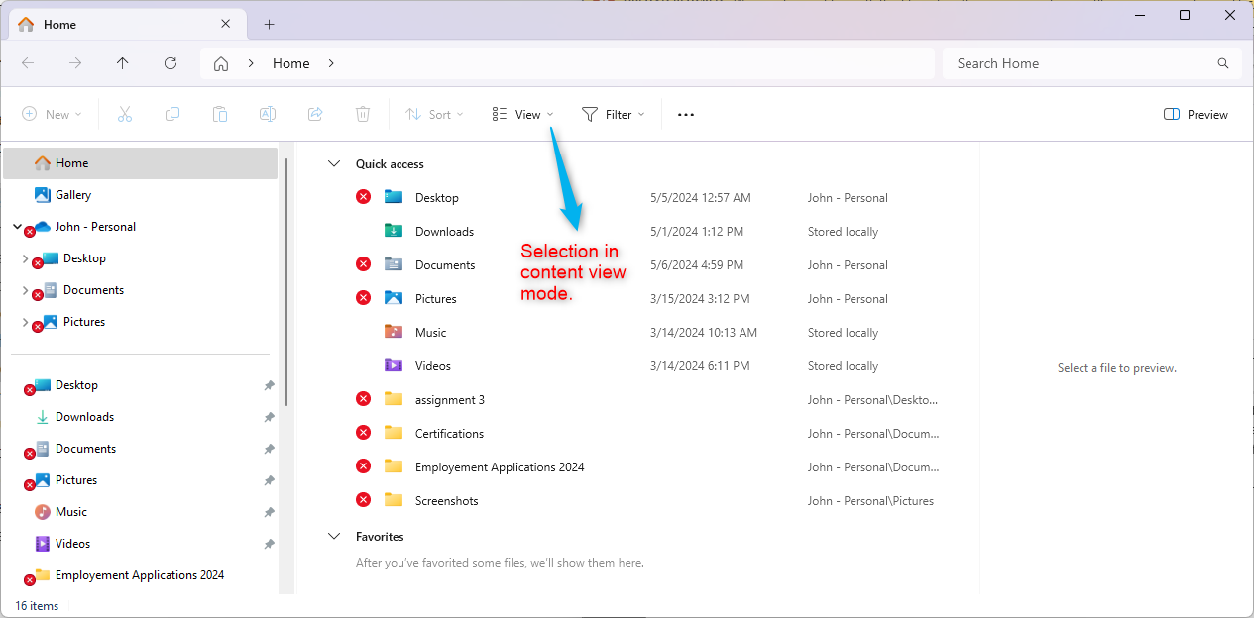

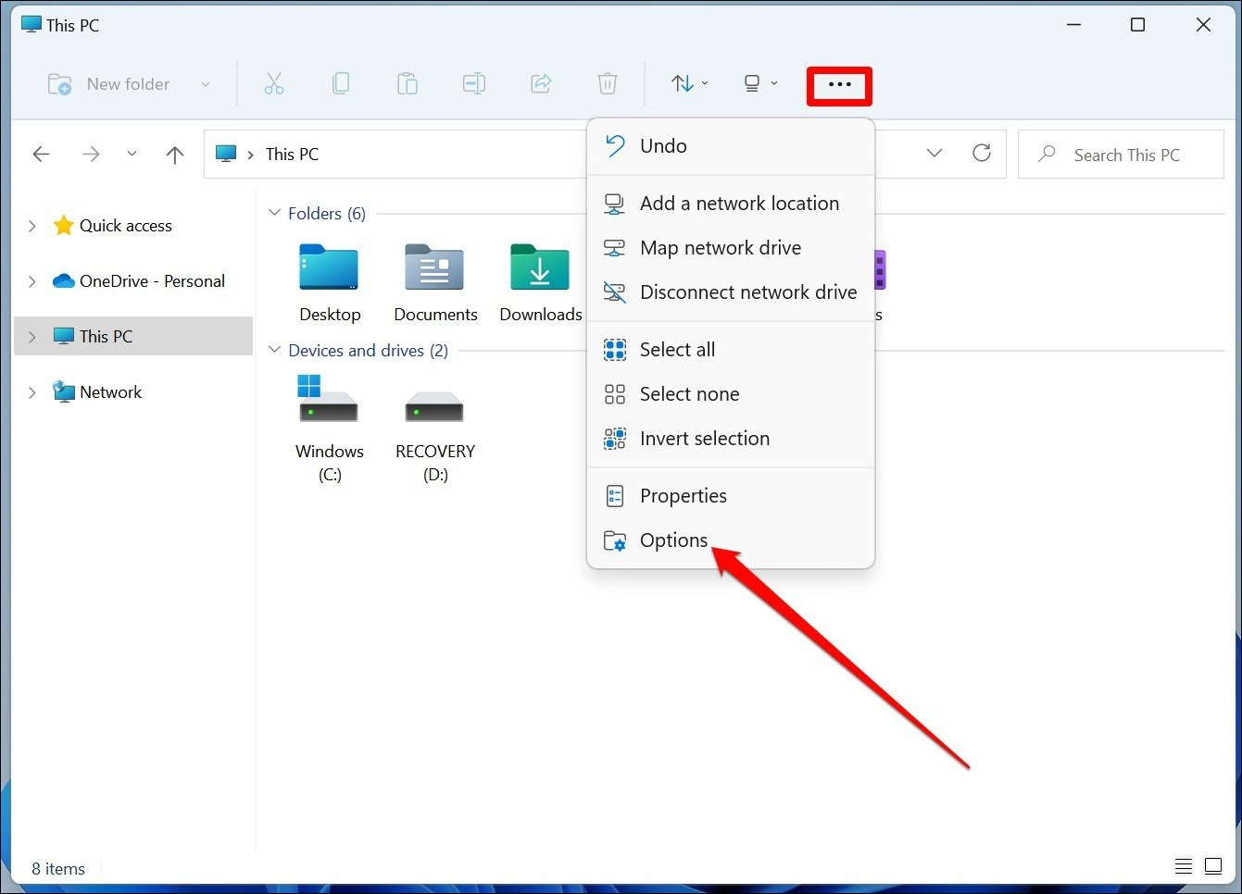

1. **Context Menu**: The context menu in Windows 11 File Explorer appears when users right-click on files or folders and provides a list of commands and options relevant to the selected item. The context menu includes common actions such as copy, paste, delete, rename, and properties and additional options for file management and customization. Users can perform various tasks quickly and efficiently using the context menu, enhancing their overall File Explorer experience.

Assignment #4 – Windows Concepts

***Understanding File Associations in Windows***

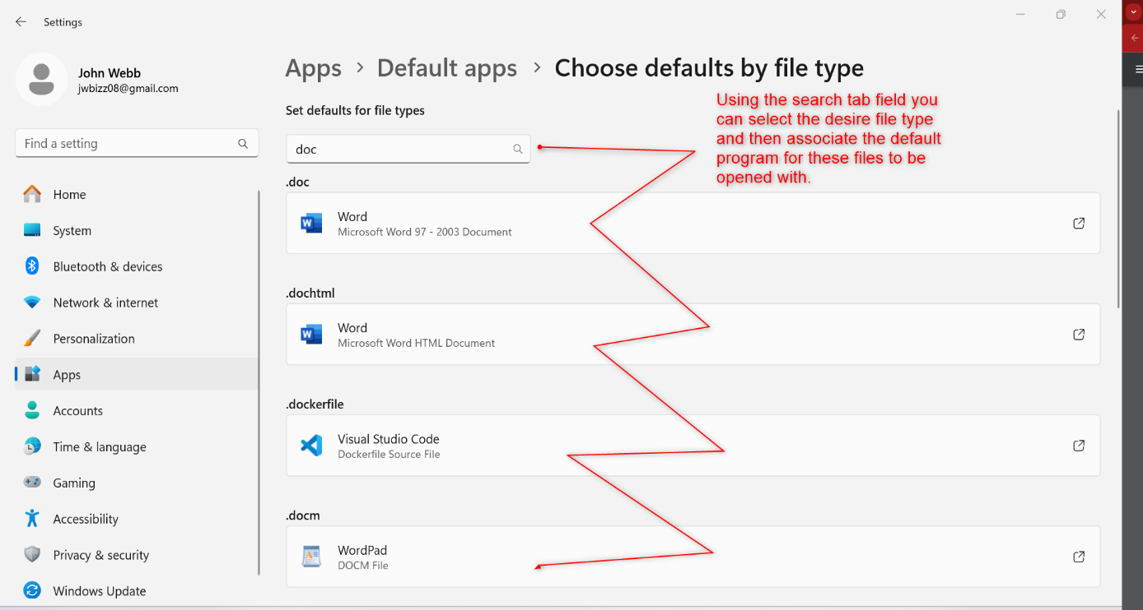

File associations in Windows determine which application is used to open a particular file type based on its extension. For example, a .docx file is typically associated with Microsoft Word, while a .jpg file is associated with an image viewer.

Windows maintains a database of file associations that maps file extensions to corresponding applications. When a user double-clicks a file, Windows consults this database to determine the appropriate application for opening the file.

Customizing file associations allows users to specify their preferred applications for opening specific file types. This customization can be done through the Windows Settings interface, where users can define default programs for different file types.

File associations ensure that files open with the intended applications automatically, enhancing user productivity and workflow efficiency.

Assignment #5 – Windows Concepts

***Backing up Files in Windows***

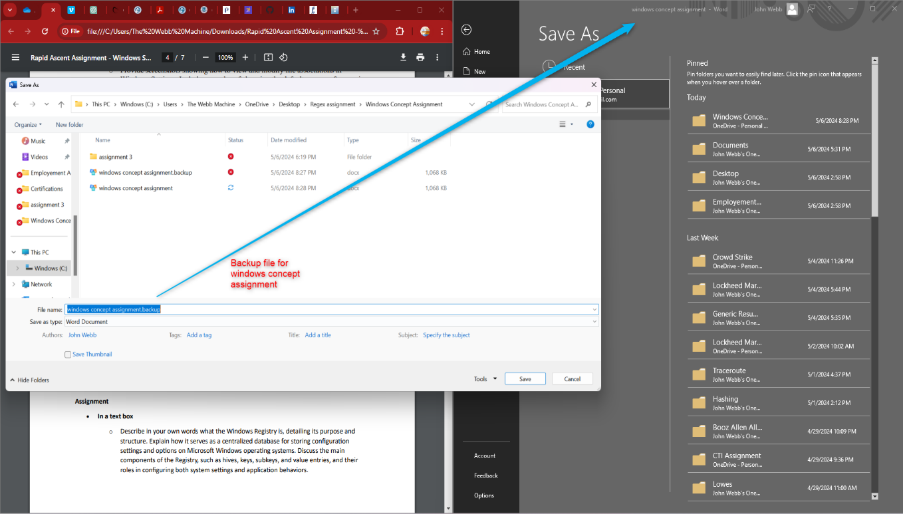

Creating a backup copy before editing a central file is essential to prevent data loss in case of accidental changes or errors during editing. This backup copy is a safeguard, allowing users to revert to the original file if needed.

To back up a file in Windows, users can copy the file to a different location or create a duplicate with a distinct file extension or name, such as appending "_backup" to the filename. Alternatively, specialized backup software or utilities can be used to automate and streamline the backup process.

Common file extensions used for backup files include. back, .backup, or simply adding a prefix or suffix to the original file name to differentiate it from the main file.

Creating backups ensures data integrity and provides a safety net for users when making changes to essential files, minimizing the risk of data loss or corruption.

***Windows Registry***

**Windows Registry Overview**

The Windows Registry is a fundamental component of the Microsoft Windows operating system, serving as a centralized database that stores configuration settings and options. It plays a crucial role in the overall functionality of the operating system by maintaining detailed information, settings, and options for both system components and installed software applications. This includes everything from user profiles to installed hardware and software settings, as well as system performance and security settings.

**Purpose and Structure of the Windows Registry**

The primary purpose of the Windows Registry is to provide a structured way to store configuration data that can be easily accessed by the operating system, applications, and services. The Registry helps Windows manage user preferences, hardware devices, and the operating environment, making it essential for the system's operation.

The structure of the Windows Registry is hierarchical, like the file system on a computer, and it is made up of several key components:

1. **Hives**: These are the top-level directories of the Registry, each of which corresponds to a specific area of the system and contains a collection of keys and values. Major hives include:
   * HKEY_CLASSES_ROOT
   * HKEY_CURRENT_USER
   * HKEY_LOCAL_MACHINE
   * HKEY_USERS
   * HKEY_CURRENT_CONFIG
2. **Keys and Subkeys**: These are analogous to folders in a file system. Keys are the containers that organize configuration data within the hives, and they can contain subkeys or values. Subkeys further organize data within a key, allowing for a structured and hierarchical organization of information.
3. **Values**: These are the settings or configuration options stored within the keys. Each value consists of a name and its associated data, which can be a number, a string, or binary data. Values are where the actual settings are stored, and they determine how hardware and software behave.

**Impact on System and Application Settings**

The Registry impacts both system settings and application behaviors in several ways. It stores user preferences, system policies, file associations, system hardware settings, information on installed software, and more. When changes are made to control panel settings, file associations, system policies, or installed software, these changes are reflected and stored in the Registry.

Applications can also use the Registry to save their settings and state information, and they often read these settings from the Registry during startup. The Registry allows for a high degree of customization and configuration, enabling both users and applications to modify the operating environment according to specific needs and preferences.

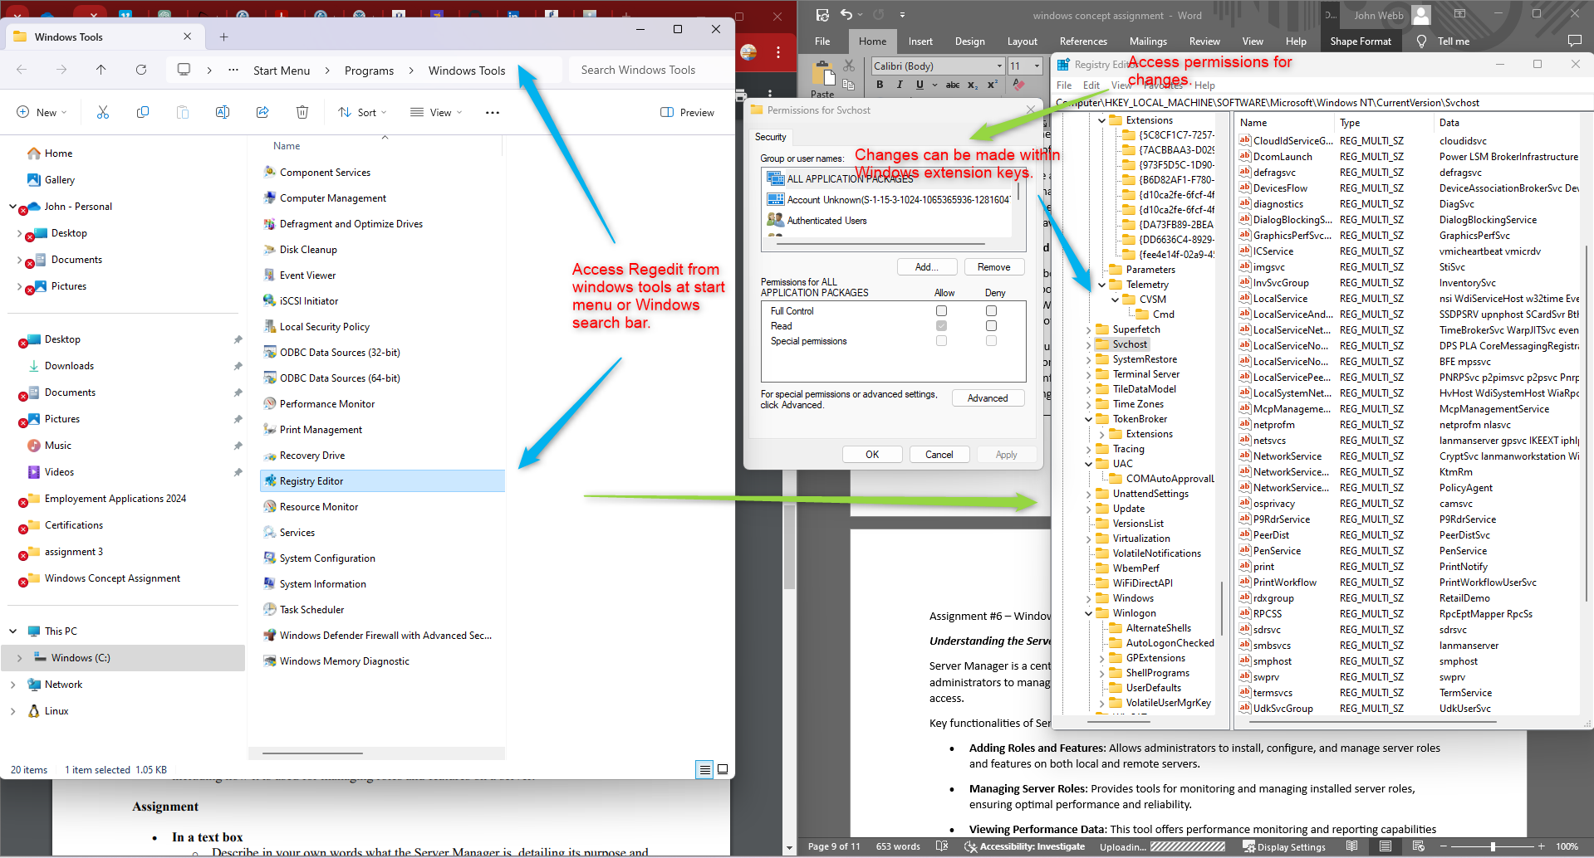

Assignment #6 – Windows Concepts

***Understanding the Server Manager Tool***

Server Manager is a centralized management tool in Windows Server environments that enables administrators to manage local and remote servers from a single interface without the need for physical access.

Key functionalities of Server Manager include:

* **Adding Roles and Features**: Allows administrators to install, configure, and manage server roles and features on both local and remote servers.
* **Managing Server Roles**: Provides tools for monitoring and managing installed server roles, ensuring optimal performance and reliability.
* **Viewing Performance Data**: This tool offers performance monitoring and reporting capabilities to track server performance metrics and identify potential issues.
* **Configuring Security Settings**: Enables administrators to configure security settings and policies to enhance server security and compliance.

Server Manager streamlines server administration tasks, simplifying the management of Windows-based servers and improving overall efficiency.

**Windows Server Manager Main Interface:**

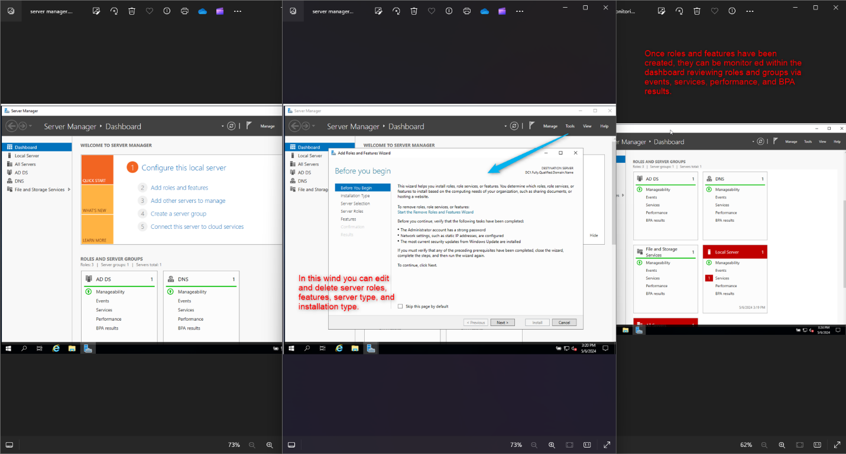

Assignment #7 – Windows Concepts

***Utilizing Event Viewer in Windows Server***

Event Viewer is a system tool in Windows Server that allows users to view and analyze system and application event logs. It is crucial for system diagnostics, troubleshooting, and monitoring.

Key aspects of Event Viewer include:

* **Event Logs**: Event Viewer provides access to different types of event logs, including Application, Security, Setup, System, and Forwarded Events, each containing specific types of event records.
* **Troubleshootin**g: Administrators can use Event Viewer to identify and analyze system events, errors, warnings, and informational messages to diagnose and troubleshoot issues.
* **Monitoring**: Event Viewer allows administrators to monitor system activities, track changes, and detect security breaches or unauthorized access attempts.

Event Viewer serves as a valuable tool for maintaining system health, diagnosing problems, and ensuring the reliability and security of Windows Server environments.

***Event Viewer and Log Analysis***

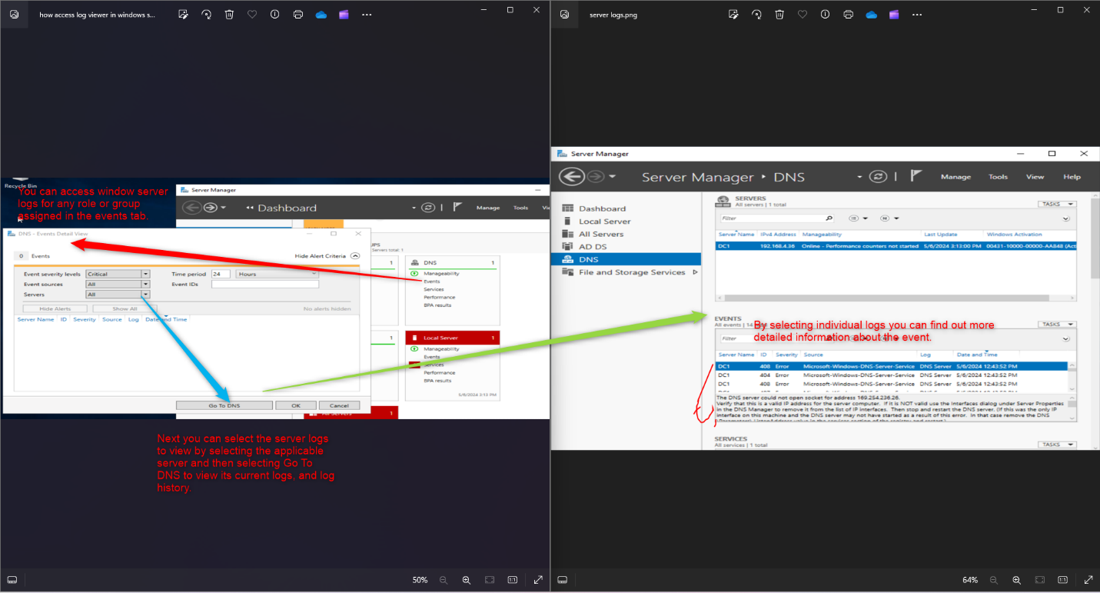

Assignment #8 – Windows Concepts

***Understanding Windows Services***

Windows Services are background processes or applications that run independently of user interaction, supporting system and application functionality on Windows Server.

Key aspects of Windows Services include:

* **Background Operation**: Services run in the background, providing essential functions such as networking, printing, security, and system maintenance without requiring user intervention.
* **Service Management**: Administrators can start, stop, pause, resume, and configure service settings through the Services management console or command-line utilities like sc.exe.
* **Service Dependencies**: Services can depend on other services or system components for operation. Managing service dependencies is crucial for ensuring service reliability and resolving dependency-related issues.

Proper management and configuration of Windows Services are essential for maintaining server performance.

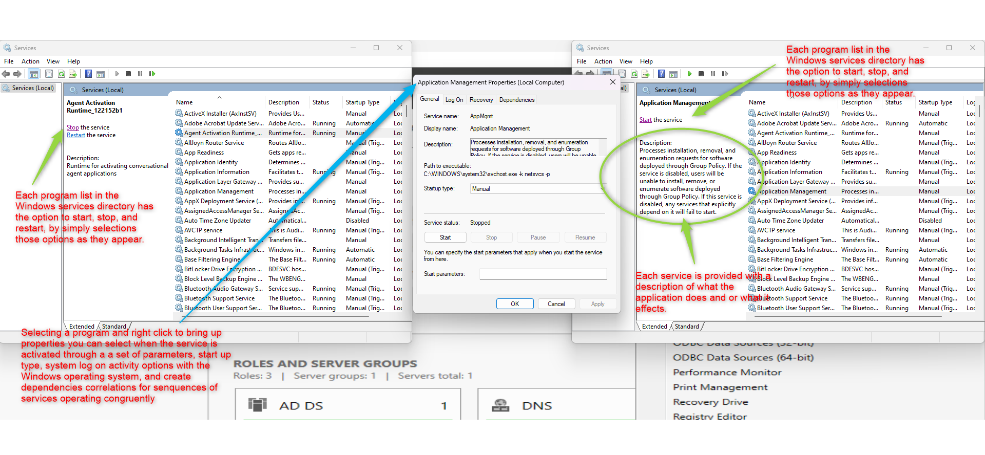

Assignment #9 – Windows Concepts

***Windows Internet Information Services***

IIS, or Internet Information Services, is a web server software developed by Microsoft for hosting websites and web applications on Windows Server operating systems. It plays a crucial role in the Windows Server ecosystem by providing a platform for delivering web content, processing requests, and managing various web-related tasks.

**Primary Functions:**

1. **Web Hosting:** IIS is a web server capable of hosting static and dynamic web content, including HTML files, images, scripts, and applications written in ASP.NET, PHP, and Python.
2. **HTTP Protocol Support:** IIS supports various protocols for communication over the web, including HTTP, HTTPS (HTTP Secure), FTP (File Transfer Protocol), FTPS (FTP Secure), SMTP (Simple Mail Transfer Protocol), and NNTP (Network News Transfer Protocol).
3. **Site Management:** IIS allows administrators to create, configure, and manage multiple websites within a single server instance. Each website can have its unique configurations, content, and security settings.
4. **Security Features:** IIS includes securing websites and applications, such as SSL/TLS encryption, authentication methods (e.g., Basic, Digest, Windows, Client Certificate), IP address and domain restrictions, request filtering, and URL rewriting.
5. **Performance Optimization:** IIS provides tools for optimizing web server performance, including caching mechanisms, compression of web content, and tuning options for managing server resources efficiently.